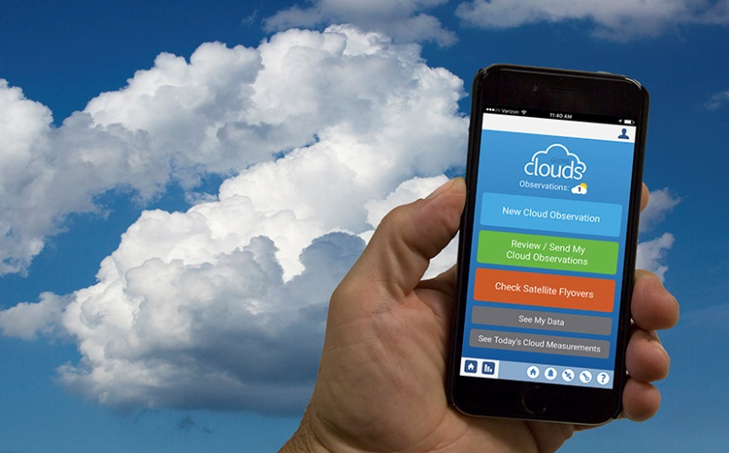
https://www.globe.gov/news-events/globe-news/newsdetail/globe/see-what-s-up-with-latest-version-of-nasa-s-globe-observer-mobile-app

The Global Learning and Observations to Benefit the Environment (GLOBE) program has released an update to the GLOBE Observer App for iOS and Android. It allows users to provide new data points on sky color, visibility, cloud properties and opacity, and surface conditions. Credits: NASA/David C. Bowman
Jessica Taylor, center, team
lead for education outreach at NASA
Langley's Science Directorate, shows
educators how to make cloud observations
with the GLOBE Observer app during a
recent workshop. Credits: NASA/David C. Bowman
There are more than two million apps available to Android and iOS users, but there’s only one NASA-developed app that allows citizen scientists to make cloud observations that complement those from NASA satellites.
Since the Global Learning and Observations to Benefit the Environment (GLOBE) program released the GLOBE Observer app in September 2016, nearly 15,000 people have downloaded it.
On March 1, the GLOBE Observer app released version 1.2, which includes updates that allow ‘Observers’ to provide new data points on sky color, visibility, cloud properties and opacity, and surface conditions.
“NASA’s view is through satellites from space, but this app adds another layer to our understanding,” said Sarah McCrea, science outreach coordinator at NASA Langley. “The ground perspective is an important piece to the puzzle.”
“The app now provides an instantaneous view from space that includes a specific match to your data,” said Jessica Taylor, NASA physical scientist and GLOBE master trainer.
The app update also supports multiple languages. Based on input from users, an optional notification system was added that lets Observers know when their local solar noon is occurring and when a satellite is flying over so they can compare their measurements with NASA measurements.
Observations from the app provide useful data of clouds, which scientists can compare to the view from above provided by satellites.
“The use of augmented reality to assist users with taking their cloud photos is pretty unique,” said David Overoye, manager of the GLOBE Data Information System. “We’re able to help Observers easily take pictures in the right direction and at the right angles.”
“It’s almost impossible to accurately estimate cloud cover near the horizon due to the nuances of light,” Taylor said. “The app ensures that observers are capturing the correct picture of their sky scene.”
These new observations, and well as other existing observations, are made simple through a few touch-and-go options for each specific data point. Users can easily navigate step-by-step through the mobile app from any location and make observations where the sky is visible then report later when an internet connection is available.
According to Lin Chambers, NASA’s GLOBE program manager at NASA Headquarters, the best part of the update aside from the additional scientific data is the “internal logic that helps to guide users through.”
Behind-the-Scenes of the GLOBE Observer App
This month, NASA Langley’s Student’s Cloud Observations Online or S’COOL program rolled into GLOBE, to align cloud protocols and work together for a more inclusive citizen science opportunity. Both programs aim to provide students and the public worldwide with the opportunity to participate in data collection and the scientific process, and contribute meaningfully to our understanding of the Earth system and global environment.
S’COOL brings 20 years, 150,000 cloud observations, and invaluable team expertise to the GLOBE Program resulting in new cloud and sky observation data points for the GLOBE Observer App in version 1.2.
The science and education teams have worked together on the specifics of the scientific observations for the app update, while Overoye led the team that made it technically possible.
Overoye’s team also built in the ability to update the app without users needing to download a new version. For example, new features, capabilities and translations will be there when an Observer opens the app.
New releases and updates to the app are on the horizon, including the ability to ask users in certain areas or certain times to support data collection of specific interests to scientists, and more opportunities to collect additional data.
GLOBE is now the major source of human observations of clouds, which provide more information than automated systems, and the educators and creators are listening and interested to hear what Observers want.
“We’re excited to see GLOBE Observer continue to grow and build a stronger community between NASA and Observers who are helping to collect this data,” Overoye said. “We do receive all of your comments and suggestions, so please keep sending us ideas on what you’d like to see.”
To learn more about GLOBE Observer or to get the app for your Android or iOS device, please visit: https://observer.globe.gov.
Watch a Facebook Live about the updated app Thursday, March 9, at 5:30 p.m. EST on the NASA Earth Facebook page.
Denise Lineberry
NASA Langley Research Center
News origin: GLOBE Implementation Office
Return to News Listing

Comments

